Loan Default Prediction Project Report

1. Introduction
The objective of this project was to develop a machine learning model to predict whether a borrower will default on a loan. Additionally, we extended the project to include a loan amortization dashboard and email reminders using Streamlit.
This project integrates:
- Data preprocessing & EDA (Python, pandas, matplotlib)
- Machine Learning (Logistic Regression, Random Forest)
- Model deployment (Streamlit app)
- Practical finance applications (loan schedule & reminders)

2. Dataset Description
We used a dataset (Kaggle source) containing borrower information and loan details.
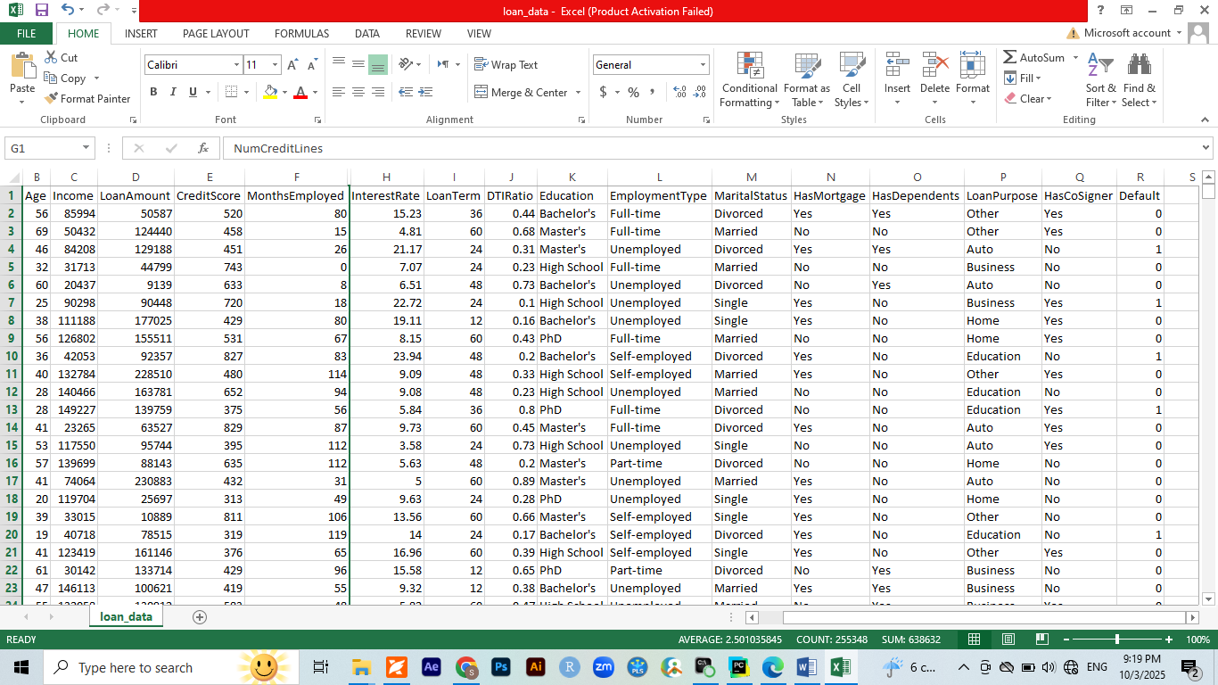
Features:
- Numerical: Age, Income, LoanAmount, CreditScore, MonthsEmployed, InterestRate, LoanTerm, DTIRatio, NumCreditLines
- Categorical (Ordinal): Education
- Categorical (Binary): HasMortgage, HasDependents, HasCoSigner
- Categorical (Nominal): EmploymentType, MaritalStatus, LoanPurpose
- Target: Default (0 = Non-default, 1 = Default)

3. Data Preprocessing & EDA

3.1 Handling Missing Values
- Checked for nulls using df.isnull().sum().
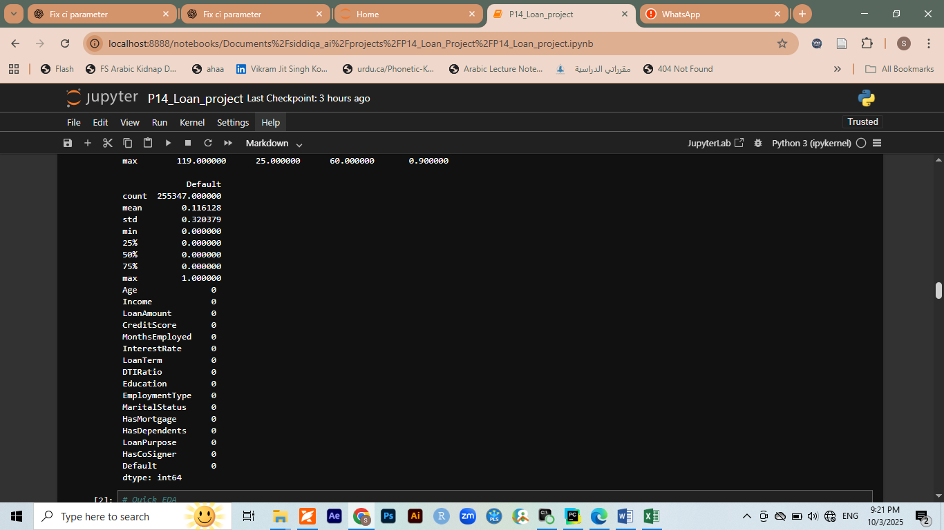
- There were no critical missing values.

3.2 Feature Encoding
- Ordinal Encoding: Education (High School < Bachelor’s < Master’s < PhD)
- Label Mapping: HasMortgage, HasDependents, HasCoSigner → mapped Yes/No to 1/0
- One-Hot Encoding: EmploymentType, MaritalStatus, LoanPurpose
- Standard Scaling: Applied to continuous numerical variables.

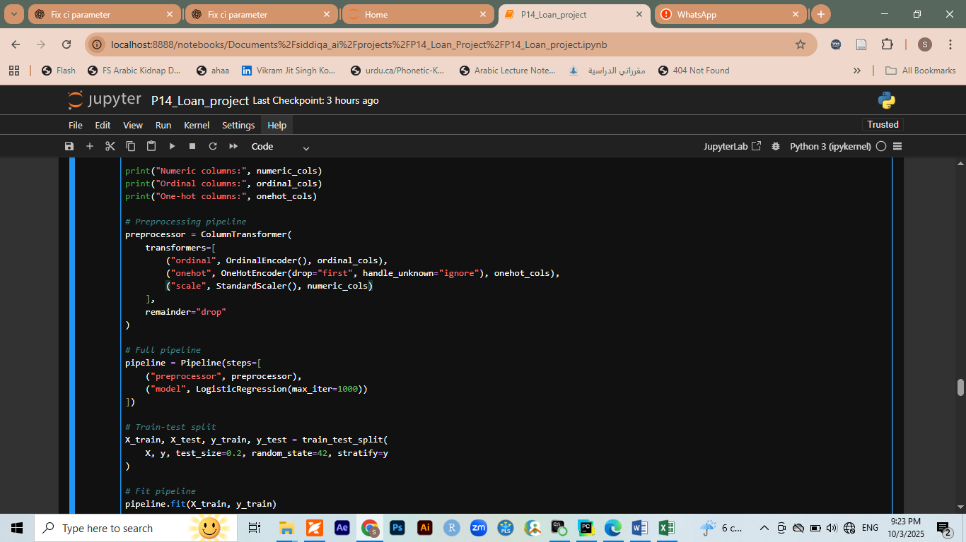
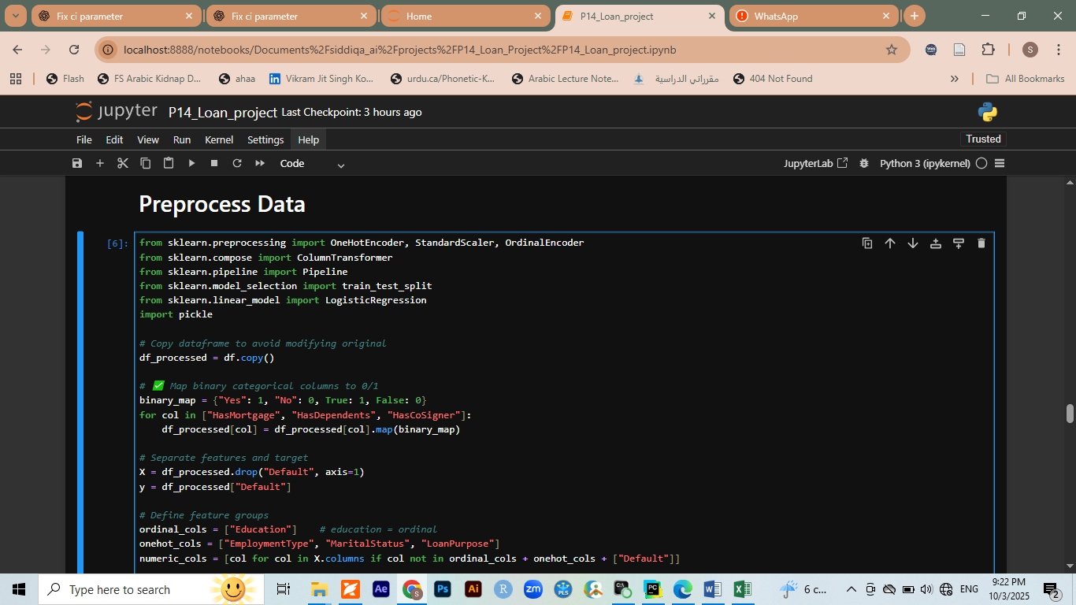
3.3 Exploratory Data Analysis (EDA)
- Distribution plots of features (Age, Income, LoanAmount).

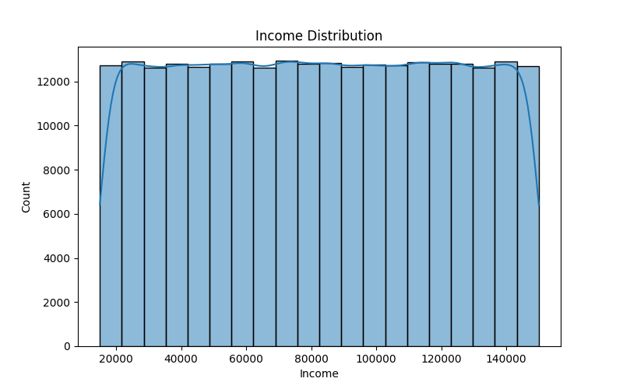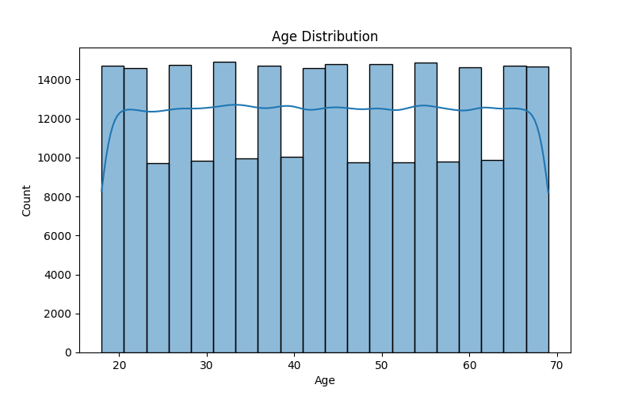

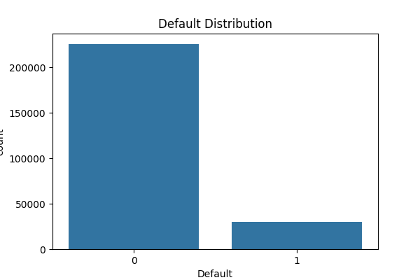

4. Model Selection

Models Compared:
- Logistic Regression
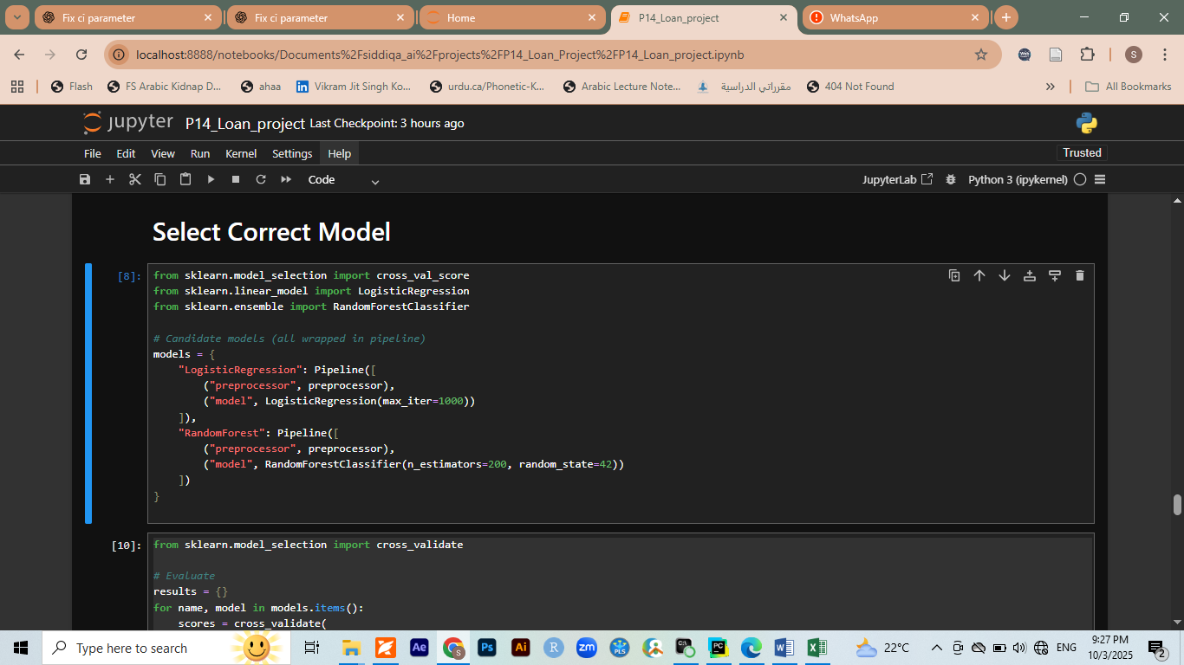
- Random Forest

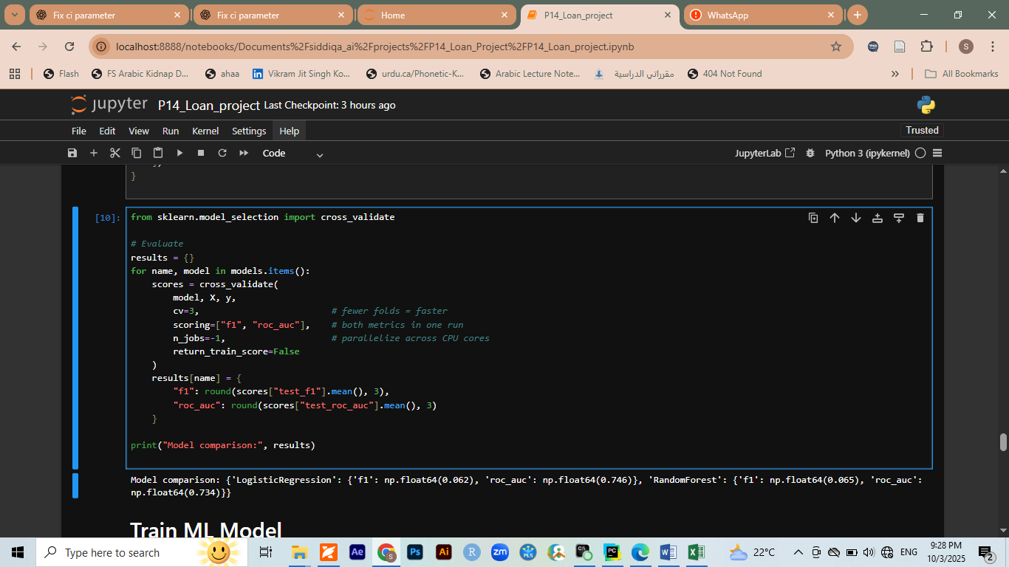

Evaluation Metrics:
- ROC AUC Score: measures overall classification performance.
➡ Logistic Regression was selected as the final model (slightly higher ROC AUC).

5. Training the ML Model
- Train-test split: 80% train / 20% test
- Final model fitted inside a Pipeline (preprocessing + model).
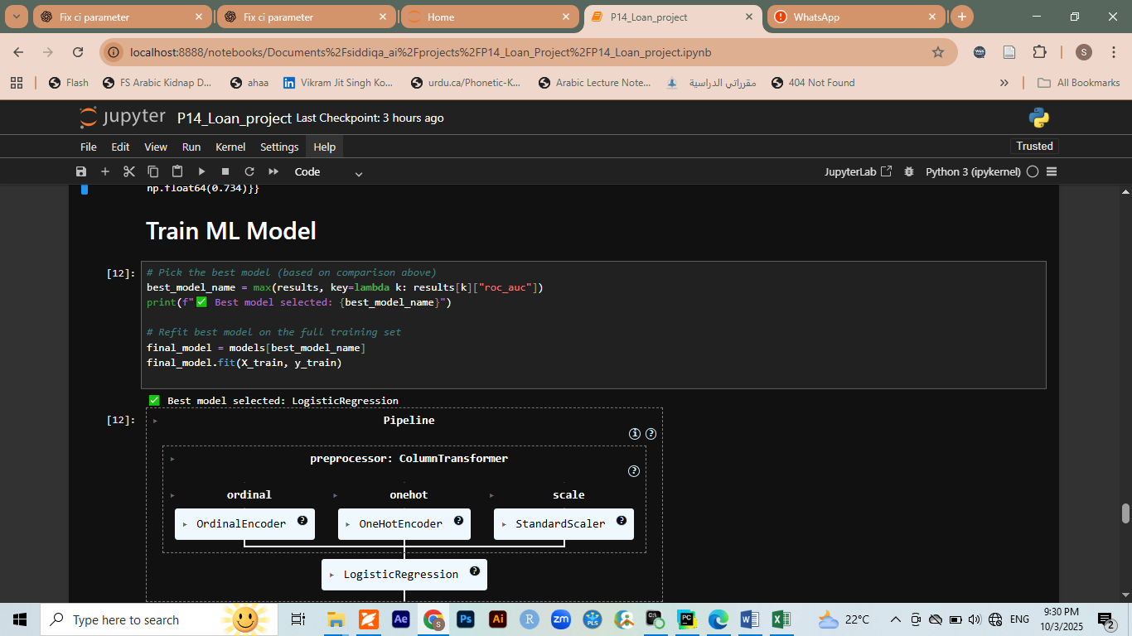
- Classification report & confusion matrix generated to evaluate predictions.

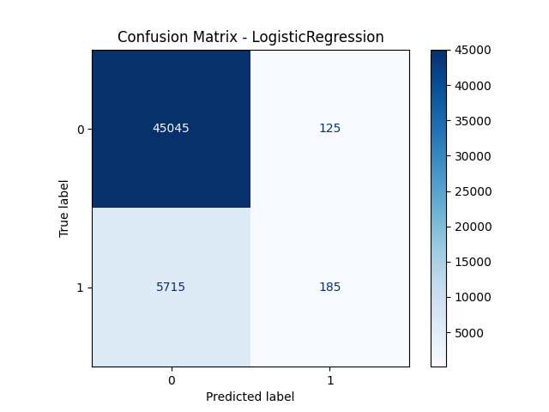

6. Saving Model
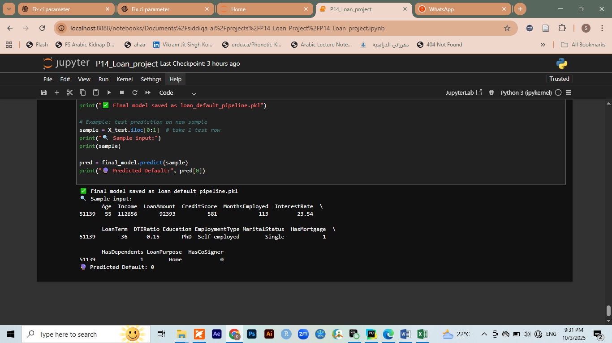
The trained pipeline was saved as a .pkl file for deployment:

7. Streamlit Web Application
We built an interactive Streamlit app (app.py) with the following features:
- Loan Default Prediction
  - User inputs borrower details via dropdowns/sliders/text inputs.
  - App displays probability of default with a risk label.
- Loan Amortization Dashboard
  - Generates monthly payment schedule.
  - Displays Principal vs Interest vs Remaining Balance with interactive charts.
- Email Reminders
  - User provides email address.
  - App sends payment reminder emails via Gmail SMTP.
(Screenshots of Streamlit app UI here)

8. Deployment

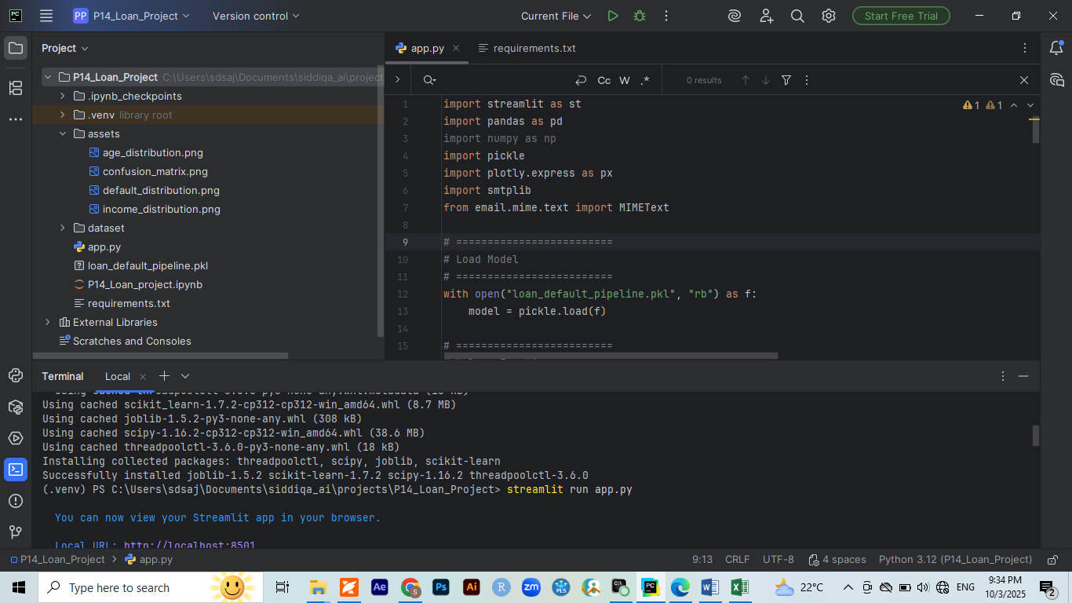
8.1 Pycharm
We generated a code for required app to be run on streamlit in pycharm
- Created repository P14_Loan_project.
- Pushed project files:
  - P14_Loan_project.ipynb
  - app.py
  - loan_default_pipeline.pkl
  - requirements.txt

8.2 Streamlit Cloud
- Linked GitHub repo with Streamlit Cloud.
- Deployed app: available publicly via generated Streamlit URL.

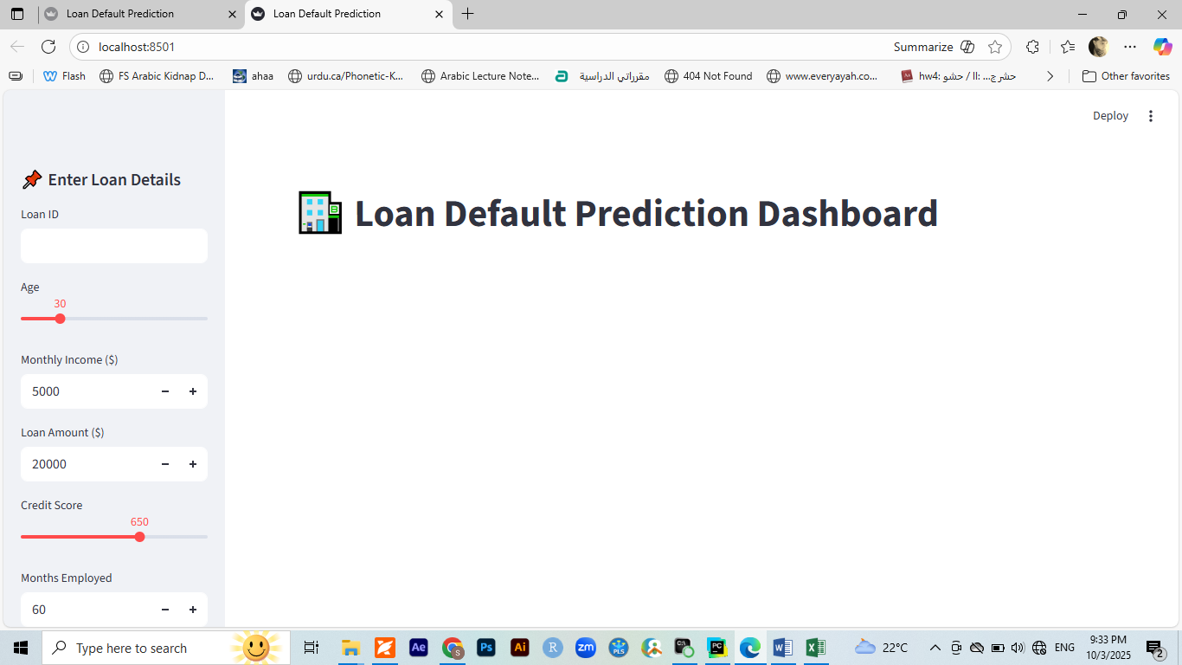

9. Conclusion
- We successfully built a Loan Default Prediction System that integrates:
  - Machine Learning (classification)
  - Finance (loan amortization schedule)
  - Deployment (Streamlit app)
  - Communication (email reminders)

